**Institute of Engineering & Management**

**Department of Computer Science & Engineering**

**Communication Engineering Laboratory for 2nd year 4th semester 2018**

**Code: CS 491**

**Date:** 12/04/18

**ASSIGNMENT- 10**

**Experiment Name:** Generation of Pulse Amplitude Modulation (PAM).

**Theory**: Pulse Amplitude Modulation (PAM) is an analog modulating scheme in which the amplitude of the pulse carrier varies proportional to the instantaneous amplitude of the message signal. The pulse amplitude modulated signal, will follow the amplitude of the original signal, as the signal traces out the path of the whole wave. In natural PAM, a signal sampled at the Nyquist rate is reconstructed, by passing it through an efficient **Low Pass Frequency (LPF)** with exact cut-off frequency.  
There are two types of sampling techniques for transmitting a signal using PAM. They are:

* Flat-top PAM
* Natural PAM

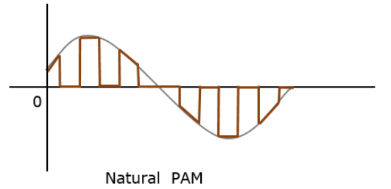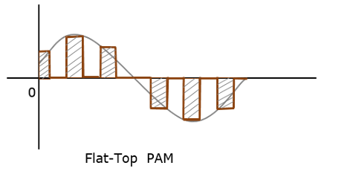**Flat Top PAM**: The amplitude of each pulse is directly proportional to modulating signal amplitude at the time of pulse occurrence. The amplitude of the signal cannot be changed with respect to the analog signal to be sampled. The tops of the amplitude remain flat.  
**Natural PAM**: The amplitude of each pulse is directly proportional to modulating signal amplitude at the time of pulse occurrence. Then follows the amplitude of the pulse for the rest of the half cycle.

**Circuit Diagram:**

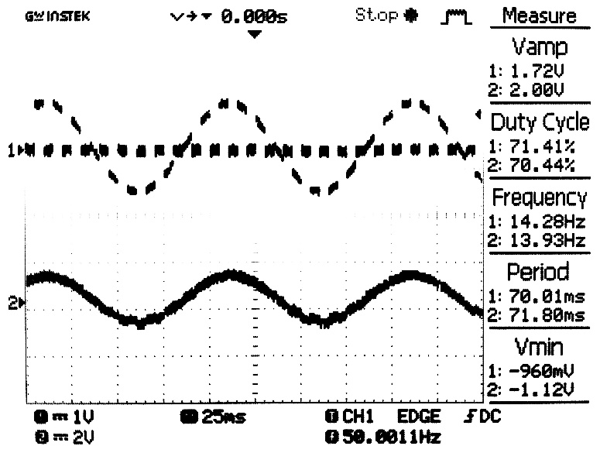**Waveform:**

Msg. Signal = 1V; Carrier Signal = 2V

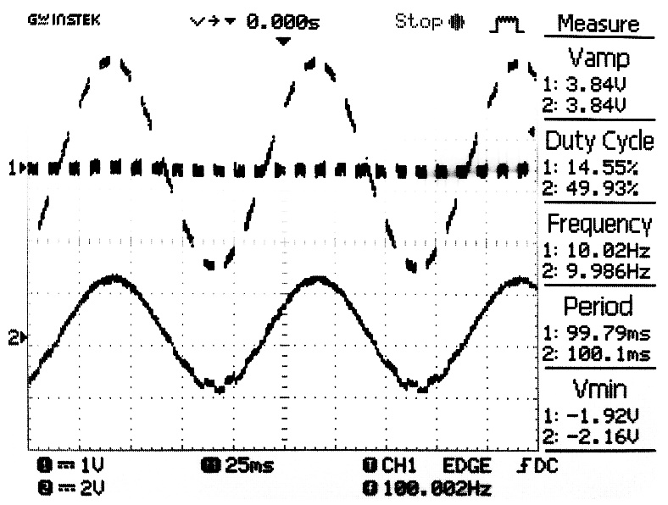

Msg. Signal = 2V; Carrier Signal = 3V

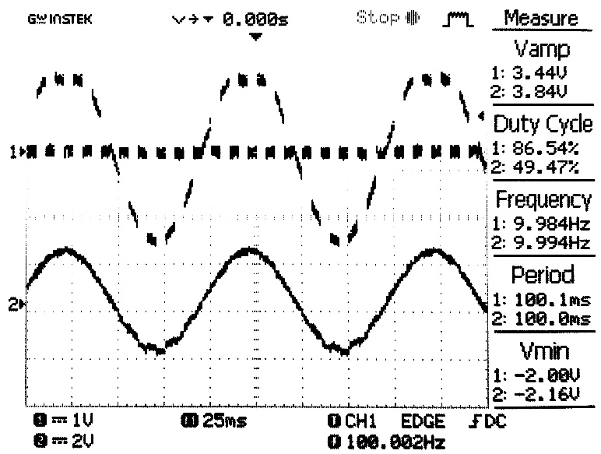

Msg. Signal = 2V; Carrier Signal = 2V

**Discussion:** In this Experiment we created message signal and carrier wave using function generator and modulated the message signal using PAM.